School-based enterprises (SBE) provide an economic, social, and educational return to the student, school, and community. The overriding goal of the SBE is to assist students with establishing and maintaining independence by complimenting real world, hands-on activities within school learning exercises and reinforcements. The overall outcome is productive adulthood (Quinn, 2009) through successive achievements. Students can directly apply their SBE experiences to self-employment, small business start-up, their work within larger organizations, and their community development activities. The planning, implementing, and evaluation units are used to show a continuous progression that reflects these efforts. Planning, implementing, and evaluating (which includes brainstorming, researching, and organizing) make SBE start up and sustainability rewarding.

Unit One: Planning
Lesson One: Name and Logo Selection
Selecting a name makes the school based enterprise real by giving it an identity.
Brainstorming Questions for students:

- Describe your product or service.
- Who will be your audience?
- Who will look at this product?
- How will you make (or produce) your product?
- What do you need to make this product a success?
- With what other products will your product compete?

Have students look for businesses with interesting names. Have a business scavenger hunt online.
Use categories for student research such as business names

• with colorful adjectives
• with superlative forms of adjectives
• that are made up or are nonsense
• that are foreign words
• that tell what the business produces or sells
• that have alliteration (repeated beginning sounds)
• that are geographic terms
• that have nothing to do with the business’s function
• that are named after people

Deciding on the name for your School-Based Enterprise early on will help you significantly with planning and budgeting for items later. In addition to your store name, you may also want to consider a logo for the School-Based Enterprise.

See the Brand/Slogan Quiz PowerPoint for identifying businesses with taglines.

Unit 1: Planning
Lesson Two: Mission, Values, and Vision
Understanding the mission of a School-Based Enterprise will help tremendously when attempting to gain support.
Mission statements identify your role as a School-Based Enterprise business and the audience you attempt to serve. The following mission statement illustrates key roles and proposed audience.

Mission
A mission statement should reflect the purpose of the enterprise: For example- the mission of Cherokee Carwash is to provide fast and courteous wash and wax services within our community to ensure customer satisfaction and provide our high school students with life skills education and entrepreneurial skills training opportunities.

Students would evaluate and refine this statement to change elements that should be emphasized. What they feel are main contributions. For example, using “high quality” or “low cost” additions.

Vision
A vision statement is a long range view of what the SBE can become or accomplish. An option could be to set goals and a time when the vision would be complete. For example, The vision of Cherokee Carwash is to double in size in three years. As the enterprise grows, the vision statement can be updated.

Values
Value statements can be used to remind everyone involved in the SBE about the core values that are applied in all aspects of the enterprise. For example, Cherokee Carwash will achieve its goals through positive learning experiences, teamwork, and support.

Classroom Activity
- Ask students to find the mission, vision, and values statements for the School System or the favorite companies in Lesson One.
- List those statements on chart paper or on the classroom board.
- Evaluate the similarities and differences.
Are they easily understood?
Can they be easily remembered? Or are they long?
- Have the students write their own mission, vision, and values statements for the SBE and then discuss them as a group.

Unit 1: Planning
Lesson Three: Developing a Business Plan and Proposal
Business plans allow you to take an inside look at your potential School-Based Enterprise success. Business plans clearly describe what your Enterprise will do, how it will accomplish your goals, why you are attempting this venture, and when you hope to accomplish your goals. Ultimately, your business plan will identify whether or not your plans are realistic.

Creating a business plan for a new or existing School-Based Enterprise will help you clearly focus on the success or failure of this business. Business plans will help to establish realistic goals and provide a sound plan for achieving your desired results. See below for an example of a Business Plan Budget for Car Wash SBE.
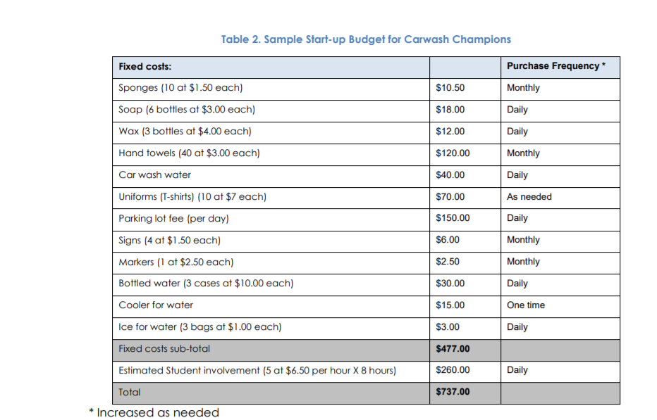

Classroom Activity- have students brainstorm all the items needed to start your SBE. Guide the conversation to include all the items. Shop online or visit a local store for community based instruction to develop your start up budget for your fixed costs or inventory list.

Unit 1: Planning
Lesson Four: Advertising
Before identifying the promotions you want to implement, it is important to first identify who your target market is and what you want to communicate to them (positioning). Most SBEs have very similar target markets such as students, parents and faculty/staff, but we can break it down even further.
For example, instead of “students”, what if we segmented students by class (freshman, seniors, etc.) or by interest (musicians, athletes, journalists)? We can speak more directly to a target market the more we narrow the target market down. Instead of, “Buy a T-shirt at the school store,” it might be more effective to have posters in the freshman hallway stating, “Welcome to Spartanburg High School! Be sure to fit in by wearing Spartanburg High gear. We are here to help you select the right merchandise at the school store!”
We refer to messaging (wording of your slogans, campaigns etc.) as “positioning,” in other words, how are you positioning your services/products in the mind of the prospective customer? Speaking to people’s emotions is very important – people buy emotionally.
The Three Tips for Advertisement
- Social Media Tactics
Using Snapchat, Instagram, and Twitter, you can blast out time sensitive coupons and have each person who comes to redeem the coupon share that coupon on a social media platform before they can use the coupon. Another impactful tactic that can be used is creating a Snapchat geofilter. You can create one of these on a very limited budget, but they have a huge reach. You can set them up during a sporting event, or any other event going on at your school and let students/parents know that if they take a snapchat with your geofilter, they will receive a discount, or something along those lines.
- Traditional Marketing Tactics
Mailings, emails and handing out fliers at events can be a very effective way of communicating to parents and faculty/staff which are two demographics that often get over-looked. Even if parents are interested in school spirit wear for themselves, they are often providing the funds for their students to purchase, so be sure to communicate with them.
Mailings can be expensive, but if you can slip an insert in with a mailing already scheduled to be sent out by the school or district, that is a great way to save a few dollars while still getting your message out there.
Emails are free and very effective. Why not check to see if your school has an email database that you could send messaging to once or twice throughout the school year?
When it comes to fliers, your best bet is to go to the where the parents are, and give them something to take back home with them. Usually events are chaotic, so just a table or booth might not be enough. Give them something they can read once they get back home, and include a compelling call to action (maybe a coupon that expires in 30 days).
- Guerilla Style Marketing
Catch your target markets by surprise, by implementing these tactics! Do things out of the ordinary that people will talk about (be sure to get admin approval when needed). Here are a couple ideas we’ve been made aware of:
- Place school store fliers on car windshields in the shape of parking tickets. This will certainly get people’s attention.
- Hang posters in the hallway upside down. People won’t be able to help but stop and turn their heads to read the messaging.
- Flash fashion show during lunch. Simply surprise the student body with a random 10 minute fashion show during lunch, showing off all the merchandise you have available in the school store.

Class Activity- Plan your marketing strategies and what would work best for your students, school and target audience.

Unit 1: Planning
Lesson Five: Promotions

Promotions are fun activities during the planning phase! Research in small business magazines online or entrepreneurial websites – and create an extensive list of promotion ideas.
A few examples for a carwash service:
- Games/Contests and Giveaways at the Grand Opening
- Frequent Customer Cards
- Seasonal Promotions (Labor Day – Free Wax)
- Refer a Friend- Gain a Free Wash

Promotional efforts alone do not ensure a successful promotion! You have to evaluate the effectiveness of the promotion. Students should collect data (using those math skills) on the following:
- Are the signs clear, attractive, and legible from a distance?
- How can additional attention be attracted, and would the associated costs be worth it? (balloons, mascot, etc)
- How are we tracking the promotional efforts? Are coupons being counted daily?
- Is the timing correct for this promotion?
- Has as much feedback as possible been gained?
- What may distract this promotion?

Class Activity: Develop a plan for promotions for your SBE and how you will evaluate the effectiveness.

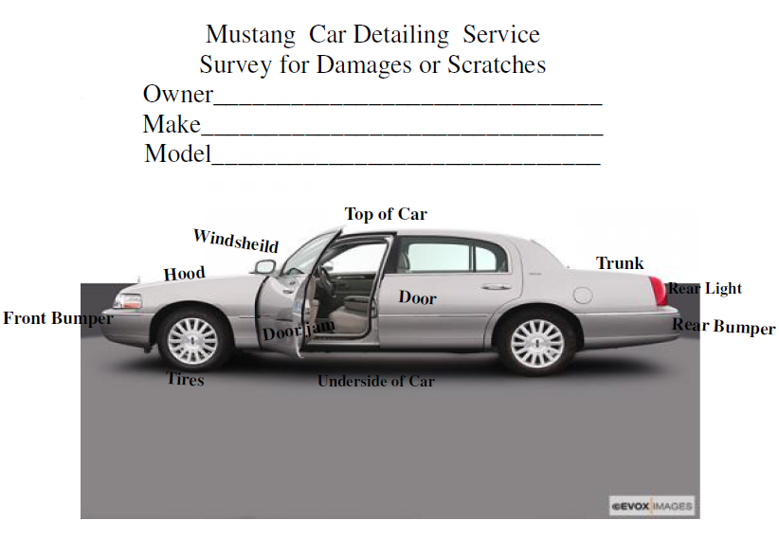
Unit 2: Implementing
Lesson One: Daily Operations

Since students are not paid wages for work in SBE, incentive programs should be implemented. The can receive points for being on time, following SBE rules, using appropriate workplace, social, and sales skills, and being active participants. Students can lose points for tardiness to work, failing to follow direction, teasing or mocking students, inappropriate language, refusing to complete job duties. You could also implement time cards with a “clock-in” procedure (on computer or an active punch in clock)
What is the flow of our business? What are the steps to implement our service or sales of our goods?
Classroom Activity: Have class develop a flow chart highlighting their idea of how the SBE should be implemented. For example, the picture above would be filled out by the car owner PRIOR to the car wash, so the SBE would not be responsible for damages that were previously on car. Have students use symbols (rectangles, arrows) to show the process- start with a simple process. See below for an example-
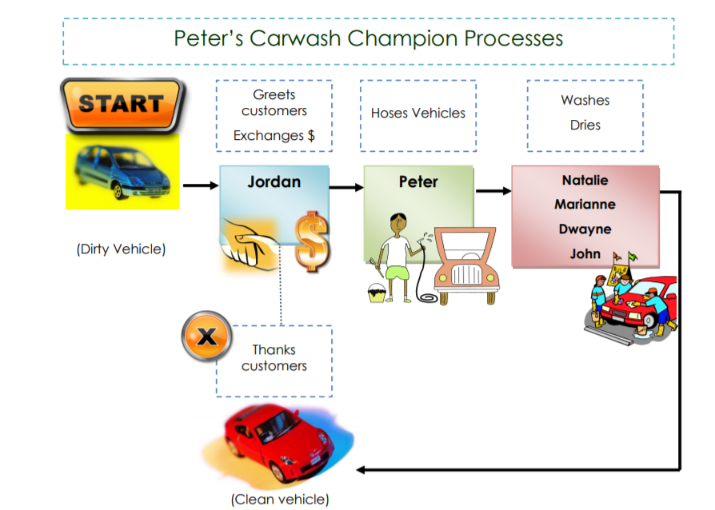

Unit 2: Implementation
Lesson Two: Positive Communication
The Skills to Pay the Bills from ODEP has a lot of valuable resources for this specific lesson.
Communication lesson from ODEP: https://www.dol.gov/odep/topics/youth/softskills/Communication.pdf
Communication occurs when a sender expresses an emotion or a feeling, creates an idea, or senses the need to communicate. The communication process is triggered when the sender makes a conscious or an unconscious decision to share the message with another person—the receiver.
Every communicative act is based on something that conveys meaning, and that conveyance is the message. The message may be either verbal (spoken or written) or nonverbal (body language, physical appearance, or vocal tone). Messages may also come from the context—or place and time—of the communication. For instance, if you choose to make a critical comment to someone, the place and the time you choose to make that comment will make a big impact on how it will be received.
Every message is sent and received through one of our five senses—it is seen, heard, touched, tasted, or smelled. The sensory media through which messages are sent and received are communication channels. In a work setting, messages may be seen through body movement, letters, memos, newsletters, bulletin board notices, signs, emails, and so on. Messages that are heard come through conversations, interviews, presentations, telephones, radios, and other audio media. Sight and sound are the two most frequent communication channels used in our society.
When the receiver gets the message (through seeing, hearing, feeling, touching, or smelling), he or she will usually give feedback (return message) unconsciously or consciously. Thus, the communications process is on-going.
The worst assumption a sender of a message can make is that the message will be received as intended. So many things can go wrong during the communications process that we should always assume that something will go wrong and take steps to prevent that occurrence. Barriers to good communications are always present. For instance, the language itself can be a barrier—unclear wording, slang, jargon, the tone. Another barrier is the failure of the sender to realize that his or her body language might contradict the spoken message. The channel used to convey the message might be wrong. For instance, you would not use the telephone to relay a lot of statistical information; you would need to write that message on paper. Poor listening skills can constitute a barrier also.

Nonverbal Communications
People telegraph their intentions and feelings, whether they are aware of it or not. They become unintentional senders. In other words, whatever goes on inside shows outside. The messages we convey to others go far beyond the words we speak. Probably over half of the meaning that others attach to our spoken message come not from the words of the messages themselves but from the tone of voice and from our body language. This nonverbal impact comes particularly from the face, eyes, body, clothing, gestures, and touch. We have to be careful not to assume that just because a person displays one nonverbal signal that we are interpreting that signal correctly. We must look at the whole cluster of signals to see if they support our reading of that person. For instance, a person who crosses his arms might be expressing defiance, but he might also just be feeling cold. We would need to check out his facial expressions and other nonverbal signs to determine the correct reading.
Most of us depend on our reading of others’ facial expressions to judge how they feel about us or a particular situation. We depend on the face as the most trustworthy indicator of emotions such as happiness, surprise, fear, anger, joy, sadness, disgust, contempt, interest, concern, and embarrassment. We also look at the face for insight into a person’s character (for example, an “open, honest face,” a “strong chin,” or “beady eyes”). A man who has a moustache, beard, or long hair might suggest conformity or nonconformity, depending on the time and the context. The grooming of hair says much about a person’s meticulousness. Narrowed lips or jutted-out chin might mean a person is angry or defiant.
The body is another rich source of nonverbal confirmation or denial of our verbal message. We draw conclusions about people before we ever exchange words based on their sex, posture, height, weight, and skin color. For instance, people often stereotype others by thinking that tall people make good leaders, overweight people are jolly, and women are too emotional. We notice how the senders of messages hold their bodies. We consider crossed arms to be a sign of defensiveness, defiance, or withdrawal. Hands on hips say that a person is goal oriented or ready and able to take something on. Leaning back in a chair with hands clasped behind the head can be interpreted as a sign of superiority, smugness, or authority. A slouched posture can be read to mean humiliation, defeat, or submission. Using our arms, bodies, and legs to block in others or things can be a sign of territorial feelings. Turning your shoulder or body slightly away from someone can be a sign of rejection of that person.
Our appearance can disclose several pieces of information about us. Someone who dresses immaculately is likely to be a careful person who attends to detail. Someone who prefers “old-fashioned” dress might be very conservative in his or her opinions and values. A person wearing excessive jewelry is possibly displaying signs of a materialistic nature. Our clothing during working hours can tell others what we do for a living. For instance, a blue-collar worker’s clothes are designed to help or protect him or her in doing the job. The white-collar worker usually wears more formal clothes considered appropriate for business but having little to do with protection.
Our most common form of social physical contact—the handshake—is often relied upon as a source of data about another person. The handshake is an indication of welcome, liking, acceptance, and greeting. Therefore, it is considered extremely rude not to accept an offered hand. The way you shake hands is another source of data about you. A bone-crushing grip can be seen as a desire to dominate and a limp grasp as a sign of insecurity or a negative outlook on life. A mechanical pumping up and down of another’s hand in a series of convulsive jerks suggests mental rigidity, strong will, and inflexibility. Other than the handshake, we have to be very careful with touching others in the workplace because of harassment issues. People who are better readers of nonverbal messages tend to do the following things:
- They look at the totality of cues rather than isolated ones (remember the crossed arms?).
- They take context (time and place) of the message into account.
- They attempt to compensate for their own biases and prejudices.

Oral Communications
People who are successful communicators take full responsibility for success in the communication process. These people take responsibility for being certain that you understand what they are saying. They recognize that barriers to good communications exist so they speak in simple, grammatical, and understandable terms. They also give examples, ask for feedback, put what they said previously in different words, and make it easy for you to gain the true intent of their communications. However, this in no way frees the listener from responsibility from the process. Without proper listening, communication does not occur.

Listening Skills
Effective listening is active participation in a conversation. It is an activity which helps the speaker become understood. The listener must actually hear and not assume what is said. A passive listener is attentive but does nothing to assist the speaker. Active listeners sit or stand alertly, maintain eye contact with the speaker, concentrate on the speaker’s words, make verbal responses, and summarize parts of what has been said when clarity is needed. Because there is a difference in how fast one can speak and how fast others can listen, a time lag exists in conversations. Good listeners do not daydream during this lag; they use the time to organize what is being said and to relate to the message. The listener must guard against distractions to the message. The speaker’s mannerisms, accent, dress or grooming, language style, or delivery can be distracting if the listener does not learn to tune them out. Also, listeners need to learn to avoid letting first impressions of a speaker color their ability to hear the message. We cannot learn anything from others if we try to do all the talking. Therefore, let speakers finish out their own sentences. Don’t interrupt them to interject your own thoughts. We need to pay attention to the tone of the words and the nonverbal cues of the speaker. Sometimes, these things undermine the actual meanings of the words themselves. For instance, someone might be telling you that he or she is not upset, but the tone or the body language might tell you otherwise.
Overall, effective listening can be expressed as follows. You should concentrate so that competing external and internal distractions are eliminated. You should probe and reflect by asking questions to seek clarification and greater understanding. You might ask “Is this what you mean?” or “Could you repeat that?” or “Are you saying that…?” Finally, you should summarize (paraphrase) and feed back to the speaker what you think you have heard. When the speaker agrees that your understanding is indeed accurate, then effective listening and effective communication have taken place.

Telephone Skills

What does telephone usage have to do with our work ethic skills? A lot, if you consider that too often we tend to forget that the person on the other end of the line is a human being. When we cannot see the person, it is easier to be rude to him or her. Anger, irritation, and frustration can be suggested by our tone of voice. Ignoring our calls and our messages suggests that we are unconcerned about our clients and customers. When we transfer callers without trying to address their concerns, we are showing a disinterested, apathetic attitude. These are just a few of the negative ways that our lack of telephone etiquette can impact our work ethics.

When we speak on the phone at work, we should always have a smile in our voice. It might sound silly, but this is easy to achieve if we actually do smile when we answer the phone. Our voices should be clear and distinct. We should show that we have a service attitude by offering to give assistance however and whenever we can. We should not transfer calls blindly without making sure that the receiving party can take care of the caller’s problem.

We must also be discreet when using the phone. Think through any requests for information and give out only information that is really needed by the caller. For instance, If someone calls asking for your supervisor, you would not say, “Mr. Jones is playing golf this afternoon.” That would be giving unnecessary information. You would say, “Mr. Jones will be in the office tomorrow morning. May I help you or have him return your call?”

We should avoid slang in telephone conversations. Instead of saying “yeah,” say “certainly.” Instead of saying “bye-bye,” say “goodbye.” Doesn’t it sound better to say “I beg your pardon. Would you please repeat that?” than to say “Huh?”

When taking telephone messages for others, don’t be in such a hurry that you do not get all necessary information. Incomplete messages are frustrating. In fact, it is a good idea to repeat the message to the caller so that you can be certain that it is accurate.

If you have to put callers on hold to gather information to handle their call, always ask their permission to do so. Or you might offer to call them back if you think they will have to wait some time before you can get back with them. As a rule, nothing irritates a caller more than to be left on hold. When you return to the phone, apologize for having the caller wait for you.

Sometimes the caller is unhappy or angry about a situation. When this is the case, be very careful. A good tactic is to let the caller vent. When he or she is finished, you will hear a noticeable sigh at which point you can express your understanding of and concern for the situation. If you let the caller vent, he or she will then be ready to listen to you and to be reasonable as you try to get to the root of the problem. However, when the venting is nasty and involves foul language, it is permissible to warn the caller that if he/she does not refrain from using such language, you will hang up. If the ugliness does not cease, you do not have to listen.

In summary, when taking calls at work, you should remember to treat the callers as you would want to be treated yourself. Also, treat them as if they were standing in front of you. Remember this: To any caller on the other end of that telephone line, you are your company. The responsibility of being your company’s sole ambassador during that phone conversation should help you remember to use correct telephone techniques.

COMEX: THE COMMUNICATIONS EXPERIENCE IN HUMAN RELATIONS, 1984, South-Western Publishing Company
OFFICE TECHNOLOGY AND PROCEDURES, 11th Ed., Fulton-Calkins, 1998, South-Western Publishing Company

Self-Appraisal Survey—Communications

Indicate how frequently you engage in the following behaviors when communicating with another person or persons. Use this scale to describe your behavior.

4 – I always do this.
3 – I often do this.
2 – I sometimes do this.
1 – I seldom do this.
0 – I never do this.

____ | 1. | When I have something to say, I am open and honest about my need to say it.
____ | 2. | I communicate with an awareness that the words I choose may not mean the same thing to other people that they do to me.
____ | 3. | I recognize that the message I receive may not be the same one the other person intended to send.
____ | 4. | Before I communicate, I ask myself questions about who my receiver is and how that will affect his or her reception of my message.
____ | 5. | As I communicate to someone, I keep a watchful eye and ear out for an indication that I am understood.
____ | 6. | I make my messages as brief and to the point as possible.
____ | 7. | I consciously avoid the use of jargon with those who may not understand it.
____ | 8. | I consciously avoid the use of slang words and colloquialisms with those who may be put off by them.
____ | 9. | I try not to use red-flag words (words that might trigger an emotional response) that may upset or distract the receiver of my message.

____ | 10. | I recognize that how I say something is just as important as what I say.
____ | 11. | I analyze my communication style to determine what nonverbal messages I send and how well they conform to the meaning I desire to get across.
____ | 12. | I carefully consider whether my message would be best understood by my receiver in a face-to-face meeting, over the telephone, or in writing.
____ | 13. | I form opinions about what others say to me based on what I hear them saying rather than what I think of them as a person.
____ | 14. | I make a genuine effort to listen to ideas with which I don't agree.
____ | 15. | I look for ways to improve my listening skills.

TOTAL SCORE

Analyze Survey Results

Score | Interpretations
50 – 60 | Are you sure you were honest? If so, you are an extremely effective communicator who almost never contributes to misunderstanding.
40 – 49 | You are an effective communicator who only infrequently causes communication breakdown. The goal of these exercises is to move everyone up to this level.
30 – 39 | You are an above average communicator with occasional lapses. You cause some misunderstandings but less than your share.
20 – 29 | Many people (at least those who are honest) fall into this category. While things could be worse, there is much room for improvement in your communication style. The goal of these exercises is to move you to a higher category.
10 – 19 | You are a frequent source of communication problems. Enthusiastically tackle the rest of these exercises and consider their implications for you personally.
Less Than 9 | Your honesty is commendable, but it will take more than honesty to improve your communication effectiveness.

Unit 2: Implementation

Lesson Three: Management

Determine Appropriate Job Responsibilities and Titles for Your SBE Staff
Operating a School-Based Enterprise requires a team approach and each member of the team should be held responsible for their particular department. The management team will also be responsible for the total operation of the Enterprise.

School-Based Enterprise team members will be responsible for each department and handle activities as illustrated below- change as necessary for your classroom.
Management Team | Responsibilities and Tasks
Store Manager – This could be teacher or teacher assistant | - Responsible for operations of the School-Based Enterprise  - Manages all of the store functions and supervises department managers
Operations Manager | - Responsible for staff training.  - Responsible for receiving merchandise and matching quantities received with Purchased Order issued  - Responsible for maintaining equipment and fixtures  - Responsible for merchandise layout and merchandise units
Sales Manager | - Responsible for sales and merchandise displays  - Responsible for designing promotional materials and promotional events  - Responsible for publicity  - Responsible for window displays
Merchandise Manager | - Responsible for ordering inventory  - Responsible for pricing inventory  - Responsible for managing inventory levels and stock status analysis  - Responsible for determining what inventory items to purchase and when inventory is needed
Finance Manager | - Responsible for financial record keeping and auditing  - Responsible for preparing financial reports  - Responsible for handling day to day cash requirements  - Responsible for verifying inventory levels and profitability of inventory items  - Responsible for determining cash requirements

Student employment positions will vary from school to school but there are many jobs or positions that will be common. Determining which responsibilities will be required for your location is the first step. Once you have identified the positions that are necessary, you should then decide who will interview prospective students and which job description will be associated with that position.

Common job descriptions and positions you may consider are illustrated below:

Position | Job Description
Manager(s) | - Responsible for management of the Enterprise and supervision of mangers and all employees  - Responsible for training employees  - Responsible for scheduling employees
Assistant Manager(s) | - Ensures that policies of manger are followed and implemented  - Works with manager and has a working knowledge of management issues  - Completes all tasks assigned by manager
Accountant | - Understands all financial records of the Enterprise and keeps all cash register records  - Prepares income statements  - Prepares inventory control statements
Merchandising Manager | - Responsible for merchandising inventory  - Assists in training employees  - Assists advertising and display managers with promotions
Advertising and Display Manager | - Responsible for store promotions  - Responsible for advertisements and store displays  - Verifies that promotions and advertisements are correct
Buyer(s) | - Responsible for ordering inventory items  - Responsible for inventory records  - Verifies payment of invoices and credit concerns  - Determines proper methods of receiving inventory

School Based Enterprise Job Application Form

Name__________________________________________________________________________________ Address ________________________________________________________________________________ ________________________________________________________________________________
Phone_______________ Grade ______ Class Period ______ Position Applying For _________________

Relevant Subjects Studied at School: School Activities _______________________________________________________________________________________ _______________________________________________________________________________________
Hobbies, Interests _______________________________________________________________________________________ _______________________________________________________________________________________

Special Honors and Awards _______________________________________________________________________________________

Work Experience

Employer’s Name _____________________________________
Address ________________________________
Telephone ____________________ Dates of Employment — From ___________ To _____________
Duties _________________________________________________________________________________
Employer’s Name _______________________________________________________________________
Address ________________________________________________________________________________ ________________________________________________________________________________
Telephone ____________________ Dates of Employment — From ___________ To _____________
Duties _________________________________________________________________________________

References
Name: ____________________________________________________________________________________
Address: __________________________________________________________________________________
Telephone: _________________________________________________________________________________
Name: ____________________________________________________________________________________
Address: __________________________________________________________________________________
Telephone: _________________________________________________________________________________
Name: ____________________________________________________________________________________
Address: __________________________________________________________________________________
Telephone: _________________________________________________________________________________

Classroom Activity: Role Play interview skills. Have students prepare their application and conduct interviews with the SBE manager. Great opportunity to practice those skills and get feedback on how to improve.

Unit 2: Implementation

Lesson Four: Policies for Money

Classroom Activity
Scenario One: Jack needs to run to the store to get supplies and the reserve cash box is empty. Should he borrow money from students to pay them back later- why or why not?

Funding is ideally never mixed. This scenario teaches students the importance of life skills. A great time to discuss credit cards (while you may not have them for SBE, it is a good opportunity to discuss interest rates and penalties)

Scenario Two: Jose forgot to add a receipt into the expenses from last week and the totals have already been completed. Should she add it to this week or make an adjustment from last week by telling the supervisor/teacher.

Any decision like these usually depend on workplace polices – and students should learn to never assume anything without discussing with supervisor.

Scenario Three: The anticipated cash for the day is $100, but you open to only $95. What should you do?

Cash handling issues such as these need careful discussion and are the responsibility of the supervisor/teacher. Need to develop considerations for this.

General Cash Guidelines

Handling cash in a School-Based Enterprise requires documented guidelines to ensure that all monies are properly accounted for. Throughout a typical day, most Enterprises will handle a large volume of cash and should have specific procedures for reconciling cash transactions.


No manual sales or transactions should be handled outside of a register system without a marketing instructor’s approval.

There are a number of acceptable guidelines for handling cash regardless of the size or number of transactions in a School-Based Enterprise. Some general guidelines are illustrated below:

General Transaction | Acceptable Procedure
Count all cash at end of each day or at the end of each shift | - Cashier should verify cash at the end of each shift with another person present.  - With Teacher or Supervisor Present
Daily cash report form completed | - Daily cash report forms reconcile starting petty cash and all cash received  - Should be signed by cashier.
Deposit daily cash with bookkeeper or designated individual | - Daily cash report should be deposited with bookkeeper or head cashier at the end of each shift.  - All monies should be secured in a safe or designated location. No monies should be left in the enterprise.
Verification of cashier’s report | - Designated bookkeeper or administrative individual should immediately verify receipt of daily cash report and provide a  copy to reporting cashier.
Correcting report errors | - Cashier and manager should immediately correct any discrepancies
Handling returns | - A supervisor or manager should handle all returns. No refunds should be made without management approval.
Hours of operation | - No sales should occur except during normal hours of operation.
Point-of-sale register system | - The most effective way to reconcile daily transactions is through a cash register system. Every location should make this a priority in operating a School-Based  Enterprise.

Develop Daily Cash Forms

Daily Petty Cash Form
School Based Enterprise
Daily Petty Cash Form
Beginning Petty Cash: |  |  |  |  | $
Coins | Pennies:
Coins | Nickels:
Coins | Dimes:
Coins | Quarters:
Coins | Half Dollars:
Total Coins: |  |  |  |  | $
Currency | $1 Bills:
Currency | $5 Bills:
Currency | $10 Bills:
Currency | $20 Bills:
Currency | $50 Bills:
Currency | $100 Bills:
Total Currency: |  |  |  |  | $
Total Ending Petty Cash (should equal beginning amount): |  |  |  |  | $
Cashier |  |  |  | Date

Unit 2: Implementation
Lesson Five: Selling Strategies

Understanding the Selling Process

Sales associates have a direct responsibility to provide exceptional customer service at all times during the selling process. Providing exceptional customer service requires that all individuals in a School-Based Enterprise understand basic elements of the sale or selling process. There are no “perfect only” ways to handle every sales situation, but understanding the sales process will give sales associates an added advantage in providing that exceptional service.

There are several basic steps in the selling process and they are outlined below:

- Pre-approach
- Greetings and Approach
- Understanding Needs and Wants
- Handling Objections
- Completing the Sale
- Suggestive Selling

Pre-approach

Understanding these basic elements allows the sales associates to be better prepared and to display knowledge of all of the products and the features and benefits of each product. Sales associates should always be aware of product cost, colors, sizes, location, and styles available in their stores.

Prior to the actual sale, the sales associates should exhibit complete knowledge of all merchandise in all departments. This is somewhat easier in a small business but certainly tougher in large businesses. However, being prepared and knowledgeable will provide the customer with the confidence that the sales associate can help satisfy their needs.

Your School-Based Enterprise will most certainly get repeat business. The likelihood of repeat business increases substantially when sale associates are prepared to communicate effectively with customers and satisfy their needs and wants.

Understanding Customer Needs and Wants

All customers exhibit different needs and wants. The key to understanding those needs and wants is to have sales associates develop a method of finding out what merchandise the customer is interested in and why they are interested in a particular product. The sales associate can accomplish this by asking the right questions, understanding the buying motives of the customer, and satisfying those motives. In most typical sales situations, the customer is prepared to purchase a specific product and will need only for the sales associate to verify that the product is available. In other sales situations, the customer will need the sales associate’s direct involvement requiring listening attentively, and asking open-ended questions to completely understand the customers’ needs and wants.

Opened-ended questions require more than a “yes” or “no” answer and will induce the customer to talk. Examples of open-ended questions are illustrated below:

- “What brings you into our store today?”
- “What particular style do you prefer?”
- “What timeframe do you have to make a decision?”
- “How did you find out about the styles we have?”

This type questioning not only requires more than a “yes” or “no” answer from the customer, but it initiates a conversation between the customer and the sales associate, allowing the sales associates to determine whether or not the merchandise is right for the customer.
The initial training sessions provide an excellent opportunity to “role play” the sales associate and the customer. Once students understand the value of asking open-ended questions, they will immediately began to focus on the customers’ needs and wants.

When customers enter your School-Based Enterprise, they may not have a particular product or service in mind. The sales associate’s greeting will set the tone for what happens next. Sales associates should ensure that a positive impression is made with the customer. There are several ways to establish a positive impression and some of those ways are illustrated below:

- Have that award-winning smile and positive greeting ready to use.
- Use the customer’s name if it is known. Respond accordingly to the customer audience. (i.e, teenager or adult).
- Be certain to provide your name and establish a dialog when the customer's name is not known.
- Try to always approach the customer first while being mindful to the customer’s space.
- Approach the customer immediately but be friendly and above all courteous

There are a few basic approaches that might prove effective when dealing with customers:

Basic Approaches | Examples of Approach
Greetings | - “Hi, my name is Corey. How are you today?”  - “Hello Mr. Huffman, how’s your son doing?”  - “How are you today, Mrs. Davis? May I help with your balloon order?”
Merchandise | - “Mrs. Davis, we’re having a special on those balloons today, let me know if I can help you.”  - “Mr. Huffman, if you’re considering those polo shirts I have some more in the stock room if you don’t find what you need.”  - “We are having a final clearance sale on those sweatshirts. Do you have a particular color in mind?”
Service | - “Good morning, may I help you?”  - “Good afternoon Mr. Huffman, are you looking for something specific?

Handling Complaints and Objections

Objections are just opportunities for sales associates. When a customer raises an objection, it should signal to the sales associate that the customer does not clearly understand the features and benefits of a product. Sales associates should anticipate objections and have a planned response ready, should the customer respond with an objection. Sales associates should resolve the customer’s concern as positively as possible. Most objections will involve questions about the price, product reliability, and/or the need for a particular product.

Many seasoned sales individuals have used the following techniques to overcome objections and resolve the customer’s concerns.

- “Let me make certain I understand your concern. You are concerned that the color might fade on this particular brand, is that correct?”
- “Yes, this is a little higher than those products at shop-and-save; but I’m confident you will agree….”
In addition to the previous techniques, there are guidelines for handling objections that focus entirely on the objection. Some of the guidelines are illustrated below:

- Use the objection as an opportunity to make the sale.
- Gain the customer’s confidence by reassuring the customer of the benefits of purchasing the product.
- Let the customer know that you are listening and understand their concern by restating the objection.
- Use the open-ended questions to gain more information on their objection.

Completing the Sale
The ultimate goal of all sales associates is to get customers to purchase their product and become a loyal customer. During the sales process there are many, many buying signals exhibited by the customer. The primary objective of the sales associate is to recognize those buying signals. The more time sales associates spend working with customers, the more they will recognize the buying signals.
There are some reasonably good signals exhibited by customers that might prove valuable to a sales associate. Some of those signals are illustrated below:

- Positive body language, affirmative nods, and clear signals of approval
- Affirmative responses to your questioning

Classroom Activity- Find videos online of different types of salespeople. Have a class discussion about their personal experiences shopping and the types of salespeople they have encountered. List characteristics of a good salesperson.

Unit 3: Evaluation
Lesson One: Goal Outcomes and Impact

Questions to help guide the process:
    - What things could have been done differently and why?
    - Is the SBE closely aligned with its mission, values, and vision?
    - Are there policies and procedures that need to be changed?
    - What additional information would be helpful?
Social Validity is the data collected on perspectives of the enterprise by teachers, students, supporters and partners. How satisfied is everyone with the enterprise in terms of

- Student development
- Perceived benefits, cost and usefulness
- Interesting activities and engaging experiences
- Fun and enjoyment
- Applicability to real world scenarios
- Being on target (meeting needs of school, students, and community)
- Quality of goods and services

Classroom Activity: Ask the students to create questions for a satisfaction survey to develop online. Start with the question to the class—how can we know if we were effective and efficient in accomplishing our mission?

Sustainability is at the core of student achievement. Ask students to reflect on their personal experience with SBE.
What have they learned and how have their relationships changed with others?
How can students support each other?
How can they develop these skills outside of the SBE?
What barriers did you overcome to be successful in your SBE?
Do they feel confident in their abilities?

Individual evaluation forms should be done on each employee and reviewed with them. This should be done at the minimum – once a semester. Monthly monitoring would be best practice. Examples of those evaluations can be found on the SC Credential website.

Sample Policies

Policy | Action Items
Cashiers | - Verify Petty Cash Fund  - Make change  - Organize cash drawer
Accepting Credit Cards | - Identify credit cards that will be accepted  - Determine minimum charge requirements  - Establish maximum requirements, if any
In House Charge Accounts | - Determine approved accounts  - Establish management approvals  - Establish guidelines for handling delinquent accounts
Accepting Checks | - Establish check acceptance policy  - Post check acceptance guidelines  - Establish check limits  - Accept checks with current date only  - Establish identification requirements
Bad Check Procedure | - Notify customer of returned check  - Establish bad check notice guidelines  - Retain check until replacement funds are received
Pricing Products | - Identify fair pricing structure  - Identify markdowns  - Establish markdown approvals
Voids, Over rings, Discounts, and Refunds | - Establish management policy
Store Hours | - Establish and post time schedule
Employee Work Schedule | - Post appropriate schedule
Accidents | - Establish procedures for reporting accidents  - Determine safety precautions to be observed
Telephone Guidelines | - Publish processing procedures for customer calls  - Publish processing procedures for personal calls  - Establish proper answering techniques
Handling Complaints | - Determine how student should handle  - Determine when to refer to management
Personal Behavior | - Establish rules regarding the sharing of sales and costs information  - Establish guidelines for conducting personal business  - Establish rules for food and beverage
Dress and Appearance | - Determine acceptable dress code  - Emphasize importance of good personal hygiene  - Establish overall appearance
Grounds for Dismissal | - Determine guidelines for handling dishonest tendencies  - Publish guidelines for addressing excessive absences or tardiness

References
